Game Hardware 3

CA Project

Submitted by Liam Ross (A00282639)

**Introduction:**

This aim of this project was to use the OpenCV python package along with trained algorithms to detect specific objects in images and videos.

For my project, the detection methods I chose were, face and eye detection, face and smile detection, car detection and number plate detection. I chose these detection methods as I found them to be the most interesting and I felt that I could generate a lot of samples. I sourced various images and videos online to use for my project, which can all be found in the Code/images and Code/videos folders. I have also included links to the original sources for all these images and videos below.

The Python package that I used in this project was OpenCV. OpenCV is an open source, cross platform, library of programming functions aimed at real time computer vision.

**Software Used:**

OS:

* macOS Monterey – Version 12.4

Python:

* Version: 3.10

Packages:

* OpenCV – Version: 4.6.0.66
* Numpy – Version: 1.23.5

Environment

* PyCharm IDE – Version 2022.2.4

Classifiers:

* haarcascade_russian_plate_number.xml
* haarcascade_car.xml
* haarcascade_frontalface_default.xml
* lbpcascade_frontalface_improved.xml
* haarcasade_smile.xml
* haarcascade_eye.xml

Python Source Code:

* CarsImage.py
* CarsVideo.py
* FaceAndEye.py
* NumberPlate.py
* NumberPlateVideo.py
* Smile.py

**Detections:**

Face and Eye Detection

Classifiers Used: haarcascade_frontalface_default.xml & haarcascade_eye.xml

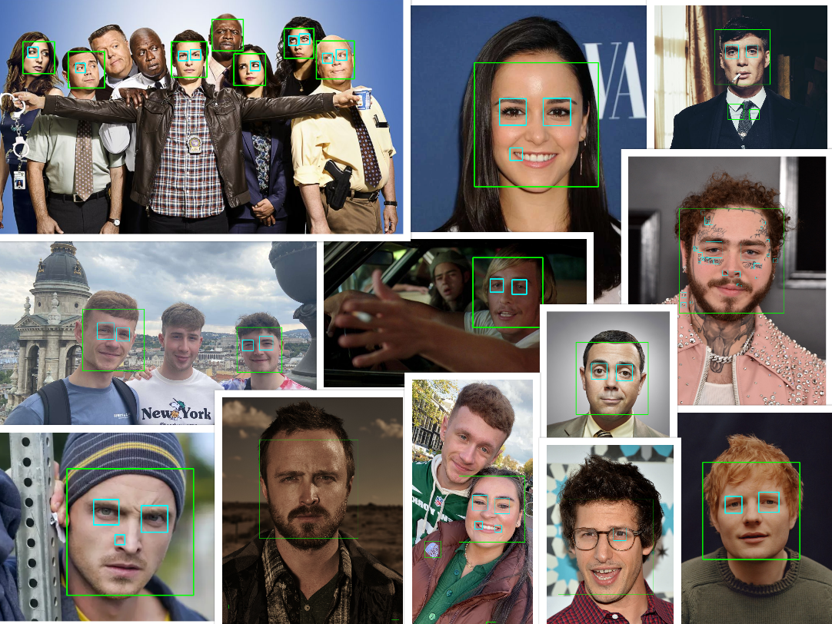

Figure : Results from Face and Eye Detection Sample 1.

Classifiers Used: lbpcascade_frontalface_improved.xml & haarcascade_eye.xml

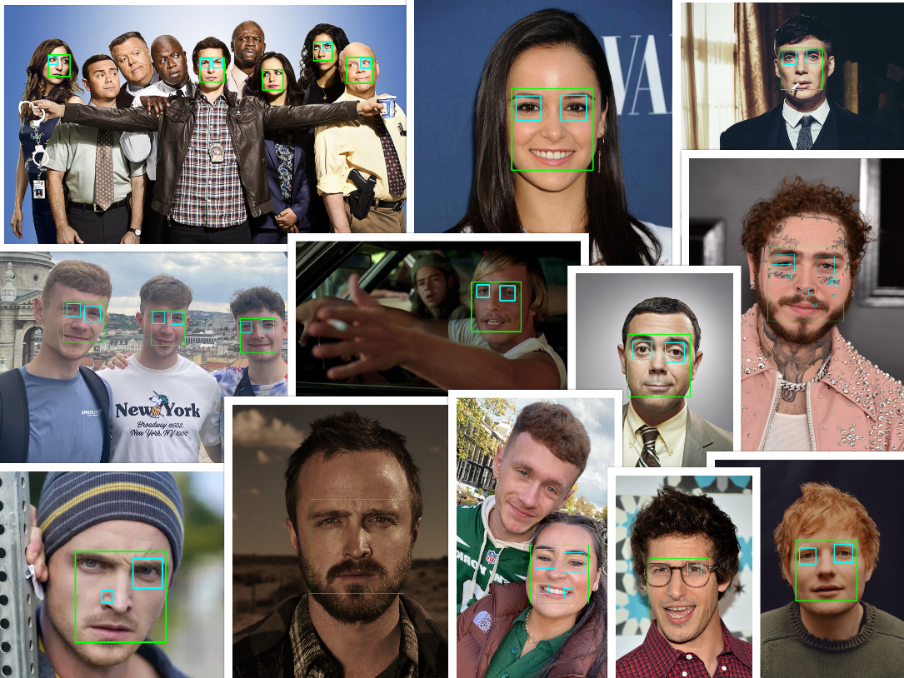

Figure : Results from Face and Eye Detection Sample 2.

For face and eye detection, I ran two detection samples with two different face classifiers on each of the sample images that I gathered. In the first sample, I used the haarcascade_frontalface_default classifier and in the second sample I used the lbpcascade_frontalface_improved classifier. I used the haarcascade_eye classifier on both samples. The green boxes indicate a facial detection, and the cyan boxes indicate an eye detection.

My goal was to see which classifier was more accurate for facial detection and what effect that had on detecting the eyes. From Figure 1 and Figure 2 above, you can see that both classifiers gave very similar results in most cases. I think that the lbpcascade_frontalface_improved classifier was more accurate in detecting faces and it gave off fewer invalid detections. As you can see from Figure 3 below, the image on the left contains two invalid facial detections around the upper chest area, indicated by the arrows, whereas the image on the right does not.

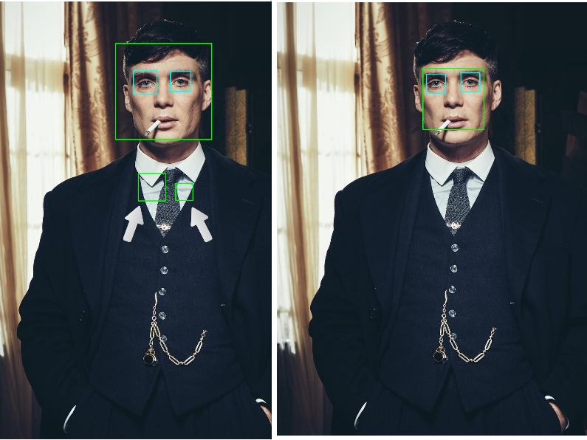

Figure 3: Left: haarcascade_frontalface_default, Right: lbpcascade_frontalface_improved

I also believe that, in most cases, because the lbpcascade_frontalface_improved classifier gave a more accurate facial detection, it led to a more accurate eye detection, as well as few invalid detections. As you can see from Figure 4 below, the face of the man in the middle on the top image was not detected at all, whereas in the bottom image, his face was detected which then led to his eyes also being detected. You can also see from the green boxes, indicating a facial detection, in both Figure 3 and Figure 4 for the lbpcascade_frontalface_improved classifier that they are much smaller than the haarcascade_frontalface_default classifier, indicating a more accurate detection.

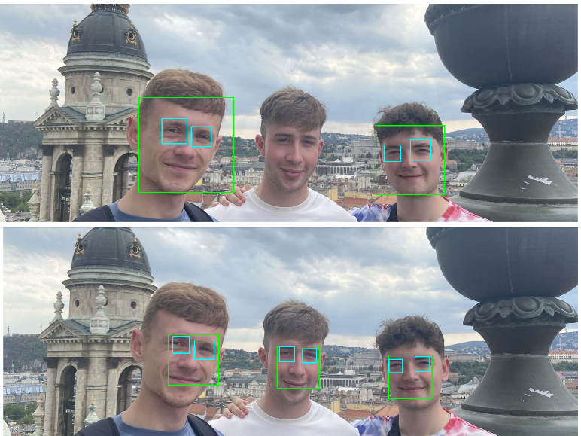

Figure 4: Top: haarcascade_frontalface_default, Bottom: lbpcascade_frontalface_improved

Face and Smile Detection

Classifiers Used: lbpcascade_frontalface_improved.xml & haarcascade_smile.xml

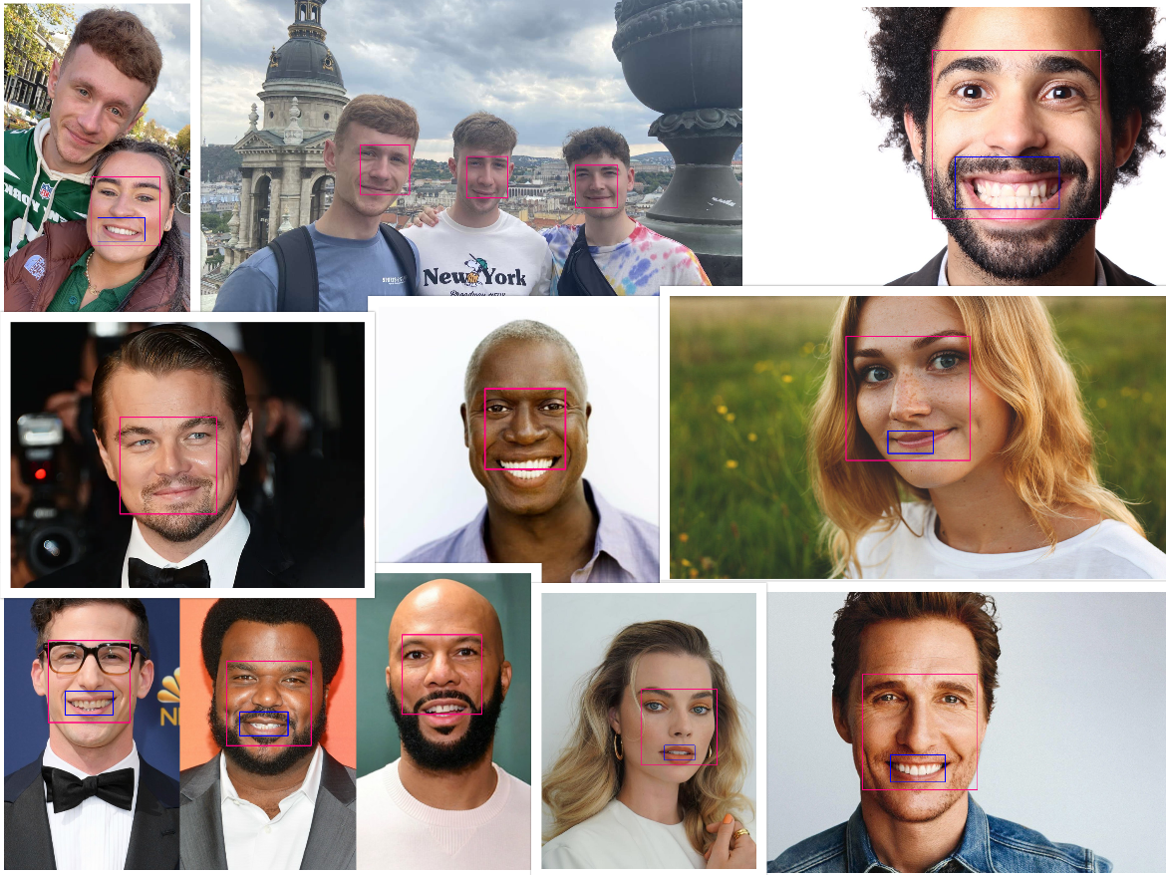

Figure 5: Results from Face and Smile Detection.

For face and smile detection, the classifiers I used were lbpcascade_frontalface_improved and haarcascade_smile. I decided to use lbpcascade_frontalface_improved for the facial detections over the haarcascade_frontalface_default as I thought it was more accurate. The results can be seen in Figure 5, where the pink box indicates a facial detection, and the blue box indicates a smile detection.

After I ran the face and smile detection samples, I found the haarcascade_smile classifier to be quite accurate. Almost all the smiles of the people in the sample images were detected. I found that the smile was better detected when the person in the image was smiling with their teeth. However, this was not always the case as in some images, the face was detected but the smile was not, even though the person was smiling with their teeth. As you can see from Figure 6 below, both men are smiling with their teeth, but their smile was not detected.

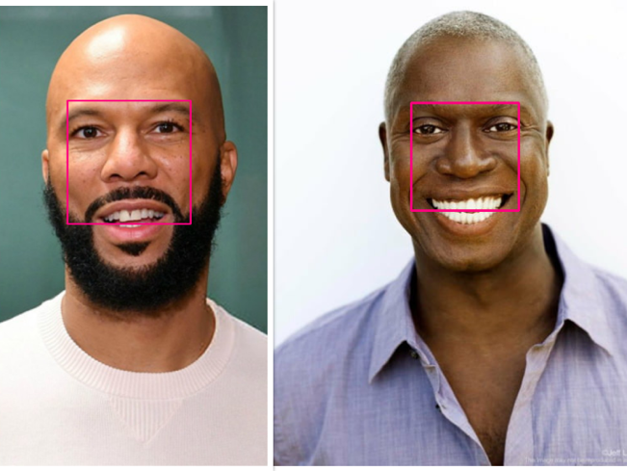

Figure 6: Smiles not detected due to facial detection.

My initial thought was the images were just bad and the classifier could not detect the smiles, however after inspecting it further, I noticed that the pink boxes around the face were very small and not very accurate. I realized then that because the face was not properly captured, this meant that the smile was not detected at all.

After realizing this, I decided to run another test specifically on the two images from Figure 6 with the haarcascade_frontalface_default classifier to see if I would get different results. The results from the second test are shown in Figure 7 and it clearly shows that the smiles were detected. As you can see the pink boxes captured more of the face which in turn allowed for the smiles to be detected.

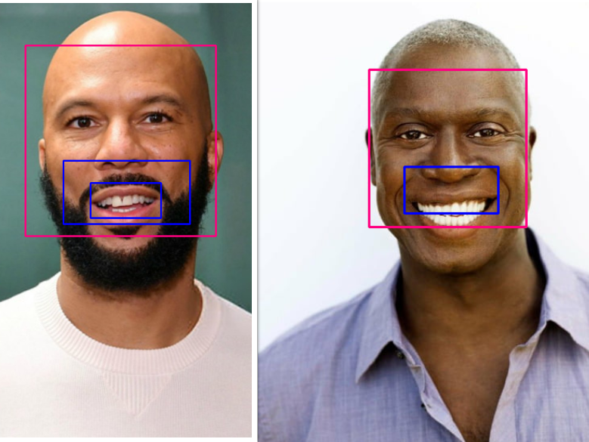

Figure 7: Smiles detected using the haarcascade_frontalface_default classifier

Number Plate Detection

Classifiers Used: haarcascade_russian_plate_number.xml

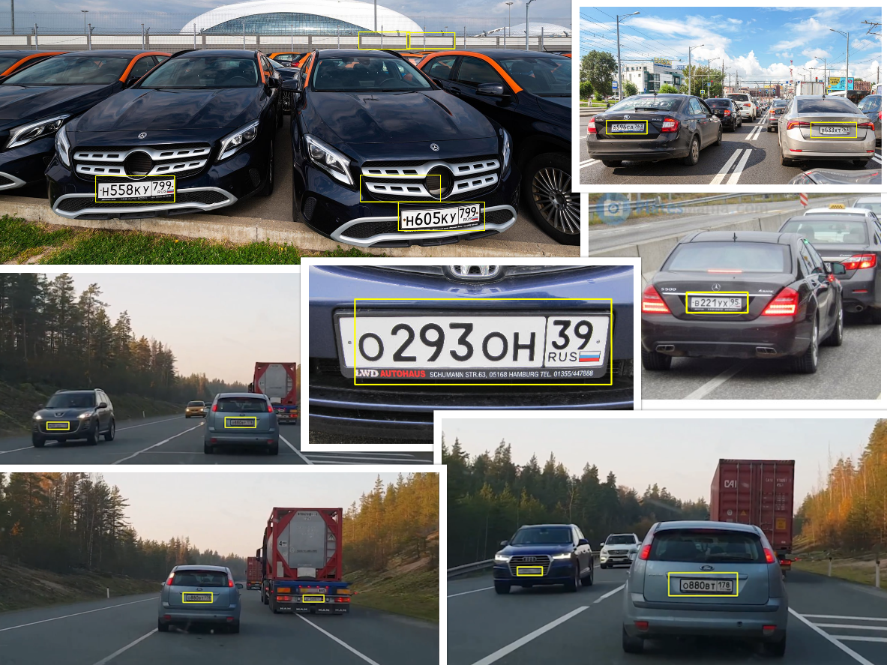

Figure 8: Results from Detection on Russian Number Plates only.

Classifiers Used: haarcascade_russian_plate_number.xml

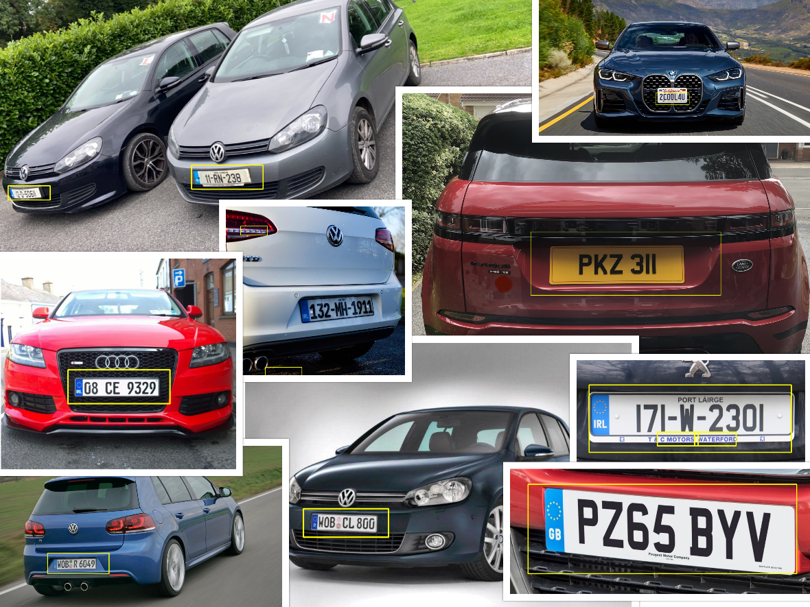

Figure 9: Results from Detection on various types of Number Plates.

For number plate detection I used the haarcascade_russian_plate_number classifier. I ran two sample detections with this classifier. In the first one, I used only Russian number plates and then in the second one, I used a variety of number plates, including Irish, English, and German. The results can be seen in Figure 8 and Figure 9 where the yellow boxes indicate a number plate detection.

I felt the need to run these two samples as I was originally under the impression that the classifier would only be able to detect Russian number plates as the name suggested. Upon running the second sample, I found myself to be wrong as the classifier worked for almost all kinds of number plates. Even though the classifier worked all number plates, I did find that Russian plates were more easily detected. As you can see from Figure 8, and closer in Figure 10, the Russian plates were very accurately detected, even from a distance, in both the sample images and sample video as the yellow boxes were almost perfectly around the number plate.

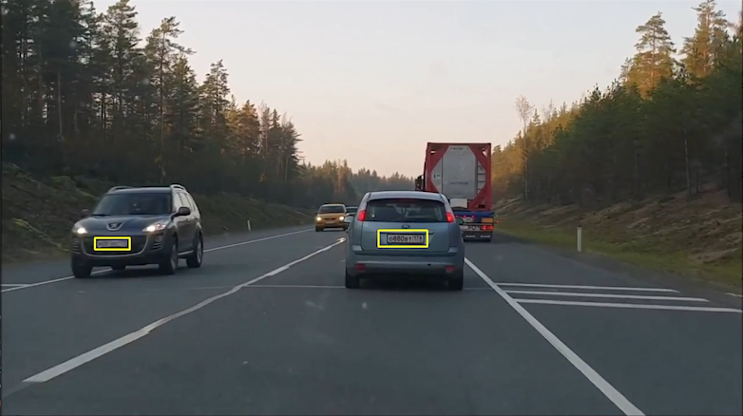

Figure 10: Accurate Russian Number Plate Detection.

As I have already states, in the second sample, as shown in Figure 9, I ran tests on Irish, English, and German number plates and I was able to get detections on these. Although I was able to get detections, I don’t believe the classifier was as accurate at detecting these types of plates. As you can see form the images in Figure 9, the yellow boxes are much bigger as opposed to the ones in Figure 8. Figure 11 shows closer view of a German number plate. As you can see the number plate is being detected, however it does not appear to be as accurate is not perfectly around the number plate.

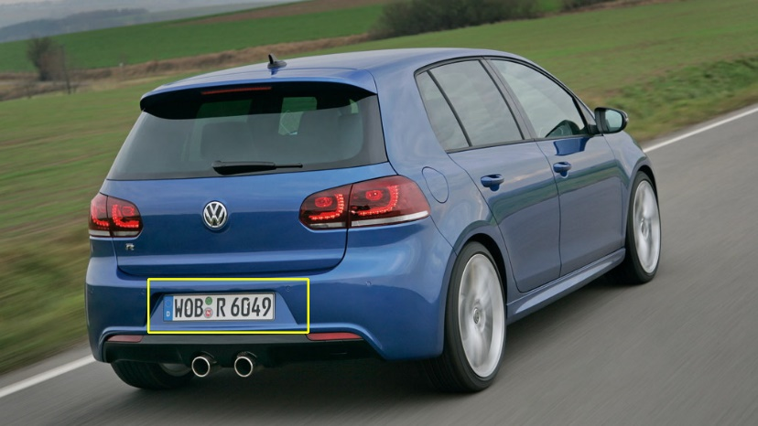

Figure 11: German Number Plate Detection.

Car Detection

Classifiers Used: haarcascade_car.xml

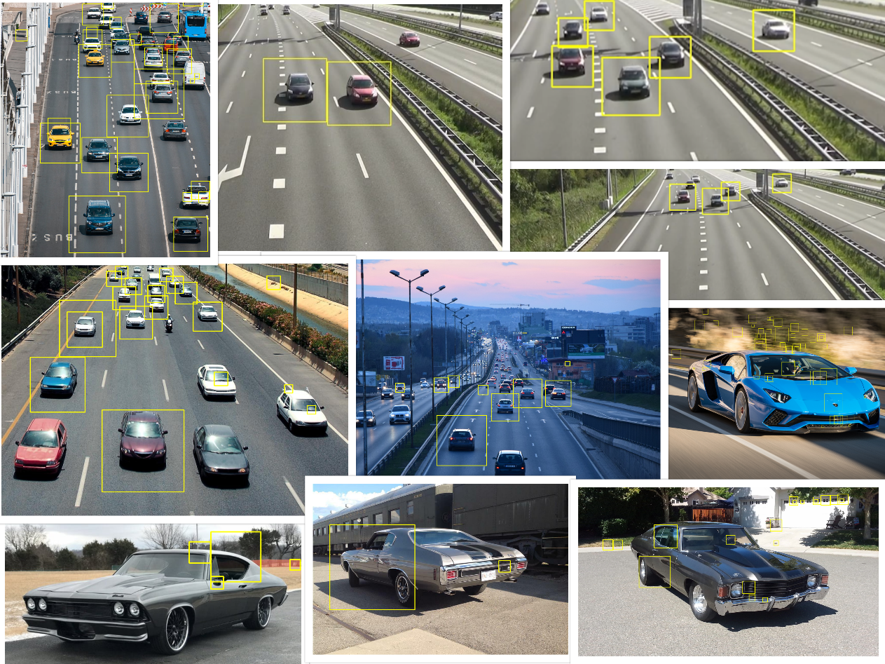

Figure 11: Results from Car Detection.

For car detection I used the haarcascade_car classifier. The results can be seen in Figure 11, where the yellow boxes indicate a car detection.

**Conclusion:**

Blah

**References:**

**Images:**

cars.jpeg: <https://tinyurl.com/mu66rndw>

cars1.jpeg: <https://tinyurl.com/5n7ksa3v>

chevelle70.jpg: <https://tinyurl.com/s34jywuc>

chevelle68.jpg: <https://tinyurl.com/yn6v8uwz>

chevelle71.jpg: <https://tinyurl.com/nh533zmx>

golf1.jpg: <https://tinyurl.com/v586avpn>

golf2.jpg: <https://tinyurl.com/2p8wmy5v>

b991.jpg: <https://tinyurl.com/49rhv3rk>

post.jpg: <https://tinyurl.com/mwcaunm4>

tommy.jpg: <https://tinyurl.com/mr3dft8p>

dazed3.jpg: <https://tinyurl.com/53w3xkdh>

smileWoman.jpg: <https://tinyurl.com/2wn2my9c>

smileMan.jpg: <https://tinyurl.com/bddfc6d4>

leo.png: <https://tinyurl.com/bddp26cr>

matthew.png: <https://tinyurl.com/3y46da5s>

boyle.jpg: <https://tinyurl.com/2627nktj>

amy.png: <https://tinyurl.com/3c3snykn>

jesse1.png: <https://tinyurl.com/yck9jswt>

jake.jpg: <https://tinyurl.com/492w6jv8>

numberPlate.jpg: <https://tinyurl.com/mrye4ykw>

numberPlate1.jpg: <https://tinyurl.com/e9daf5yf>

numberPlate2.jpg: <https://tinyurl.com/6rm9ash7>

numberPlate3.jpg: <https://tinyurl.com/yansb2r4>

americanPlate.jpg: <https://tinyurl.com/bdhst93h>

irishPlate.jpg: <https://tinyurl.com/bdz4uanh>

irishPlate1.jpg: <https://tinyurl.com/4p6kkpjn>

irishPlate2.jpg: <https://tinyurl.com/4vubauzf>

englishPlate.jpg: <https://tinyurl.com/bdd9ntz7>

englishPlate1.jpeg: <https://tinyurl.com/yxnd4e9d>

**Videos:**

cars.mp4: <https://tinyurl.com/mr2upffk>

numberPlateVid.mp4: <https://tinyurl.com/msu98beb>

**Classifiers:**

haarcascade_russian_plate_number.xml: <https://tinyurl.com/tkdufr4p>

haarcascade_car.xml: <https://tinyurl.com/tkdufr4p>

haarcascade_frontalface_default.xml: <https://tinyurl.com/tkdufr4p>

haarcasade_smile.xml: <https://tinyurl.com/tkdufr4p>

haarcascade_eye.xml: <https://tinyurl.com/tkdufr4p>

lbpcascade_frontalface_improved.xml: <https://tinyurl.com/9rzv9c57>